**3TABLE OF CONTENTS**

1. Abstract ---------------------------------------------------------------------------------------------------- 2
2. Problem Statement --------------------------------------------------------------------------------------- 3
3. Existing Solutions ----------------------------------------------------------------------------------------- 3
4. Uniqueness of the idea ----------------------------------------------------------------------------------- 4
5. Projects Tests Cases & Rules Sets --------------------------------------------------------------------- 5
6. Team Information ---------------------------------------------------------------------------------------- 6
7. Top Level Diagram ---------------------------------------------------------------------------------------- 7
8. Assumptions & Constraints ----------------------------------------------------------------------------- 9
9. Integrated Masters Schedule -------------------------------------------------------------------------- 9
10. References ------------------------------------------------------------------------------------------------ 10

**INSIDER TRADING**

**ABSTRACT:**

Insider trading is, at its core, profiting on nonpublic information by trading a company’s stock before the news investors need becomes public. This project tackles the problem by using a *Rules Engine* and a shared multi-company behavioral pattern repository to analyze and detect insider trading activity. The model also uses probability based on past occurrences to determine the legitimacy of the event.

**PROBLEM STATEMENT:**

Insider trading occurs when someone who has a [fiduciary duty](https://www.thebalance.com/the-fiduciary-duty-for-investors-357219) to another person, institution, corporation, partnership, firm, or entity makes an investment decision based upon information related to that fiduciary duty that is not available to the general public. This insider information allows them to profit in some cases and [avoid](https://www.thebalance.com/investments-new-investors-should-avoid-357226) loss in others. (In the Martha Stewart/ImClone scandal, the latter happened to be the case.)

Insider trading can also arise in cases where no fiduciary duty is present but another crime has been committed, such as corporate espionage.  For example, an organized crime ring that infiltrated certain financial or legal institutions to systematically gain access to and exploit non-public information, perhaps through the use of computer viruses or recording devices, might be found guilty of insider trading among other charges for the related crimes.

Insider trading was not considered illegal at the beginning of the twentieth century; in fact, a Supreme Court ruling once called it a “perk” of being an executive. After the excesses of the 1920s, the subsequent decade of [deleveraging](https://www.thebalance.com/what-does-deleveraging-mean-357641), and the resulting shift in public opinion, it was banned, with serious penalties being imposed on those who engaged in the practice.

**EXISTING SOLUTIONS:**

Insider trading is a threat that will always exist. The very nature of the crime dictates that it is a difficult one to eliminate. Inside information can be used intentionally by those who wish to deceive and defraud for personal gain. But it can also be shared innocently by those who may not realise the consequences of their actions until it is too late.

There are two key steps every organization can take to help combat the threat of insider trading.

* **Communication:**

Regular communicating with employees about the threat of fraudulent activities such as insider trading is essential.

This can be done through:

* Implementation of compliance policies which outline what every employee needs to know about insider trading and other crimes and what their legal obligations are.
* Designating a compliance officer – each of your compliance policies should identify a compliance officer whom employees can raise any queries, suspicions or concerns about insider trading and other issues.
* **Education & Training:**

Regular education is something which underpins the success of any business. And when it comes to matters of compliance and ethics programs, awareness training plays a vital role.

Changing regulations in every industry is making training increasingly more important. Consequently, every organization should run mandatory compliance training on an annual basis for employees at every level. Training certifications that confirm training attendance and familiarity with the terms of the compliance policy should be required.

Many organizations are choosing to use engaging and innovative new methods of training for employees. Advances in technology over the past decade have meant that an abundance of training types now exist which make the learning experience a more enjoyable and effective one for employees.

* **Insider Trading Software:**

[Vigilanté](http://www.insider-trade.com/) is a web based application which helps the Compliance Officer to centrally manage, track and follow up on all compliances pertaining to Insider Trading. It allows the Compliance Officer to set up its trading policy, announce opening and closing of trading windows, provide pre clearance approvals based on prescribed limits, capture trade details and also initial and periodic holdings of insiders. This helps the Compliance Officer to generate all reports at a single click.

Apart from [Vigilanté](http://www.insider-trade.com/) there are many more insider trading softwares such as

[BasisCode Insider Trading Manager™](http://basiscode.com/solutions/insider-trading/), [Uberall PracticeLeague's Corporate Legal](http://www.practiceleague.com/corporate-legal-department/insider-trading.html), etc

that help in monitoring and detecting insider trading activity in an organization.

**UNIQUNESS OF IDEA:**

* Rules Engine
* Rule Ranking / Precedence
* Probability of Legitimacy
* Multi-Company Behavioural Pattern Repository
* Open Source Repository

**PROJECT TEST CASES & RULE SETS:**

* **Benchmark Tests:**
  + If any transaction type was executed within 15 days of a company merger or acquisition (M&A) announcement, then generate a case for analysis.
  + If any transaction type was executed within 15 days of a major corporate announcement, then generate a case for analysis. (announcement criticality >= 5)
* **Critical Tests:**
  + If a "buy" transaction type was executed within 15 days of a subsequent 10%-day stock price move upward, then generate a case for analysis
  + If a "buy" transaction type was executed within 15 days of a subsequent 20% stock price move upward over 7-days, then generate a case for analysis.
  + If a "short" or "sell" transaction type was executed within 15 days of a subsequent 10%-day stock price move downward, then generate a case for analysis.
  + If a "short" or "sell" transaction type was executed within 15 days of a subsequent 20% stock price move downward over 7-days, then generate a case for analysis.
* **Major Tests:**
  + If more than 5 separate transactions of any type were executed within a single portfolio within a 7-day timeframe for the same stock, then generate a case for analysis.
  + If a transaction dollar amount is more than 10% of the portfolio's size (in $), then generate a case for analysis.
  + If a portfolio manager transacted outside his/her's investment specialty twice in the same day, then generate a case for analysis.
  + If a portfolio manager executed more than 3 trades outside his/her default exchange, then generate a case for analysis.
  + If a "short" was executed on a security within an industry where there is a secondary position for in the portfolio, then generate a case for analysis.
  + If a portfolio manager transacted on an individual security within 3 or more portfolios on the same day, then generate a case for analysis.
  + If a portfolio manager transacted on a security within the same industry of a disclosed conflict of interest company, then generate a case for analysis.
  + If a portfolio manager transacted on a security under an MNPI trade restriction by another portfolio manager, then generate a case for analysis.
  + If a position's share size reaches more than 10% of a security's outstanding shares, then generate a case for analysis.

**TEAM INFORMATION:**

* **Christy Joseph Anoop**
  + *Role & Responsibility*: UI development and Project Formulation
  + *Background*: Application Development and Data analysis
* **Faris Sumadi**
  + *Role & Responsibility*: Finance expertise and SQL development
  + *Background*: Financial Technology
* **Ashwin Madhu**
  + *Role & Responsibility*: Trading Expertise SQL development
  + *Background*: Business Operations
* **Yuzhe Li**
  + *Role & Responsibility*: Establish MySQL table and develop table connection
  + *Background*: Database Development
* **Sindhu Raghavendra**
  + *Role & Responsibility*: UI designing
  + *Background*: Technology Consultant in Storage domain

**TOP LEVEL DIAGRAM: (Abstract Hand Sketch)**

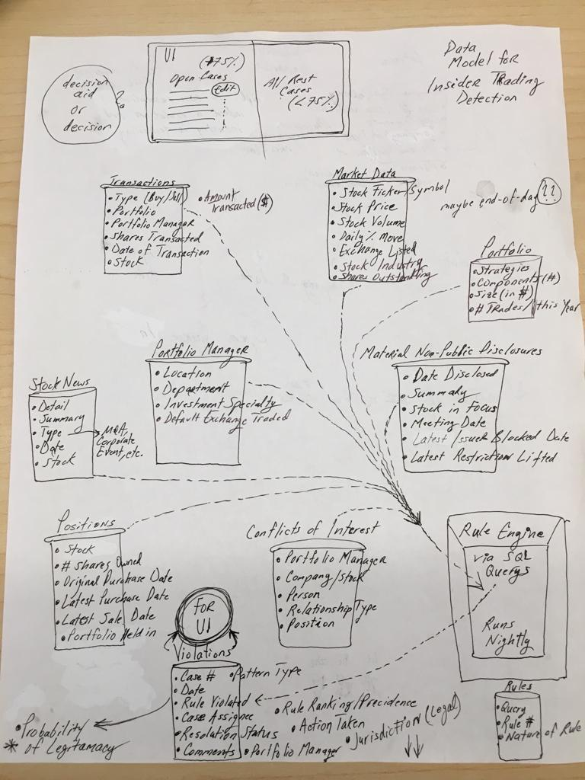

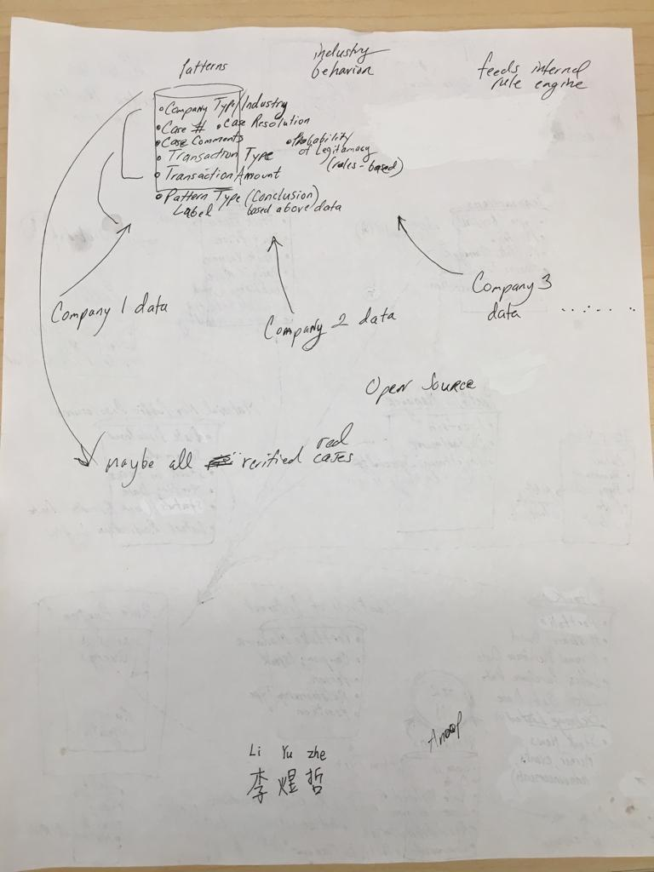

**ASSUMPTIONS & CONSTRAINTS:**

This project assumes that companies and data repositories will agree to integrate into our application; this is essential in order for our rule engine to query effectively. The data has to be uniform, complete, and maintained from an integration perspective; otherwise results would produce faulty insider trading cases for analysis to review.

We are considering building a component displaying verified insider trading cases for analysts to reference. These may be used to enhance the rule engine based on evolving patterns. A constraint here is that external companies will be restrictive in what they share due to privacy concerns.

Initially we will assume potential insider trading cases all need to be analyzed/reviewed by analysts via a user interface. However, there will be a discussion on whether our rule engine serves as a decision tool or a decision aid. Regardless, our product will display the probability of a case being a true instance of insider trading based on the significance of the rule in the rule engine.

**INTEGRATED MASTERS SCHEDULE:**

1. *September 2018:* 
   1. Project Abstract Proposal
   2. Project Formulation
   3. Role Designation
   4. Basic Rules Formulation
2. *October 2018:*
   1. ERD Development
   2. Activity Diagram Development
   3. UI Design Prototyping
   4. Research on Data Sources
   5. Rules Formulation
   6. Backend & DB Implementation
3. *November 2018:*
   1. Start of Project backend development
   2. Parallel prototyping of UI to meet user requirements
   3. Initial integration of Frontend and Back End
   4. Rules Tweaking & Modification
   5. UI Implementation
4. *December 2018:*
   1. User Feedback
   2. UI & Backend polishing based on user Feedback
   3. Develop Sales pitch
   4. Showcase & present Idea

**REFERENCES:**

1. <https://www.thebalance.com/what-is-insider-trading-and-why-is-it-illegal-356337>
2. <https://www.youtube.com/watch?v=2BtawLeS5fM>
3. <https://www.investopedia.com/ask/answers/what-exactly-is-insider-trading/>
4. <https://interactiveservices.com/latest-news/insider-trading-the-threat-the-solution/>
5. <http://www.insider-trade.com/>
6. Deanna Caputo, Marcus Maloof & Gregory Stephens, “*Detecting Insider Theft of Trade Secrets*” , 2018, pp. 14 - 21
7. <https://www.investopedia.com/articles/investing/021815/how-sec-tracks-insider-trading.asp>